Rolling correlation: AUDUSD and EURGBP
Method 05 / daily log returns / windows 20, 60, 100 / Low-value

Study setup
Logical pair: AUDUSD , EURGBP
Broker symbols: AUDUSD_i , EURGBP_i
Tier: Low-value (low_value)
Snapshot: 2026-11-03_majors_alpari_D1
Timeframe: D1
Matched return window: 1999-01-06 to 2026-11-02 (UTC bar dates)
Matched return count (rows before rolling): 7198
Dropped unfinished last bar dated 2026-11-03 UTC after a tick-volume check against the prior complete day.
Rolling windows W: 20, 60, 100 trading days
Live-shaped n for each score: n = W (not the full history length)
Complete matched rows (CSV): AUDUSD-EURGBP_Rolling_D1.csv
Complete matched rows (HTML): AUDUSD-EURGBP_Rolling_D1_data.html

Method carried forward
Rolling Pearson r is computed on matched daily log returns of close, ln(close_t / close_t-1), in the broker quote direction. Quotes are not inverted. For each day t with a full window, r_W uses the last W matched return pairs ending at t. That live-shaped sample size is W (20, 60, or 100), not the full multi-year history. The first W-1 days have no score. r is symmetric under swap of the two symbols. A high |r| in one window does not prove cause, lead-lag, or a trading signal. Short windows are noisier; long windows are slower to reflect a break.
How to read a live day: after both daily candles close, the newest r_20 uses the last 20 matched log returns, r_60 the last 60, and r_100 the last 100. Compare those three to each other and to the full-sample baseline below. A break is when the short window moves far from the baseline or flips sign while the baseline was meaningful.

Full-sample Pearson baseline (method 01 v001)
Copied full-sample Pearson r for AUDUSD-EURGBP: 0.038173. This is a historical average link, not the live state.

Rolling results
W | latest_r | mean | median | min | max | std | pct_|r|>=0.4 | pct_|r|>=0.7 | n_roll
20 | -0.141629 | 0.046811 | 0.041112 | -0.825132 | 0.894461 | 0.308699 | 22.06 | 1.57 | 7179
60 | -0.003735 | 0.038999 | 0.033804 | -0.651256 | 0.654989 | 0.238606 | 11.47 | 0 | 7139
100 | -0.094151 | 0.037674 | 0.031929 | -0.600576 | 0.592882 | 0.221223 | 7.9 | 0 | 7099
n_roll is the number of days that had a complete window. pct_|r|>=0.4 and pct_|r|>=0.7 are the share of those days where the absolute rolling correlation cleared the threshold.

Conclusion
For AUDUSD and EURGBP, full-sample Pearson baseline r=0.0382. Latest rolling scores: r_20=-0.1416, r_60=-0.0037, r_100=-0.0942. Stability: moderate window-to-window variation. Agreement with baseline: r_20=-0.142 opposite sign vs baseline; r_60=-0.004 opposite sign vs baseline; r_100=-0.094 opposite sign vs baseline. Tier line: low interest — still near zero in recent windows. This is a monitoring summary, not a trade signal.

What to look at in this file next time
1) Latest r_20 vs r_60 vs r_100 in the results table. 2) Whether short-window latest has the same sign as the baseline. 3) The rolling chart for stretches where |r| collapsed. 4) The CSV if you need a different chart later.

Charts
Rolling Pearson r (20 / 60 / 100)
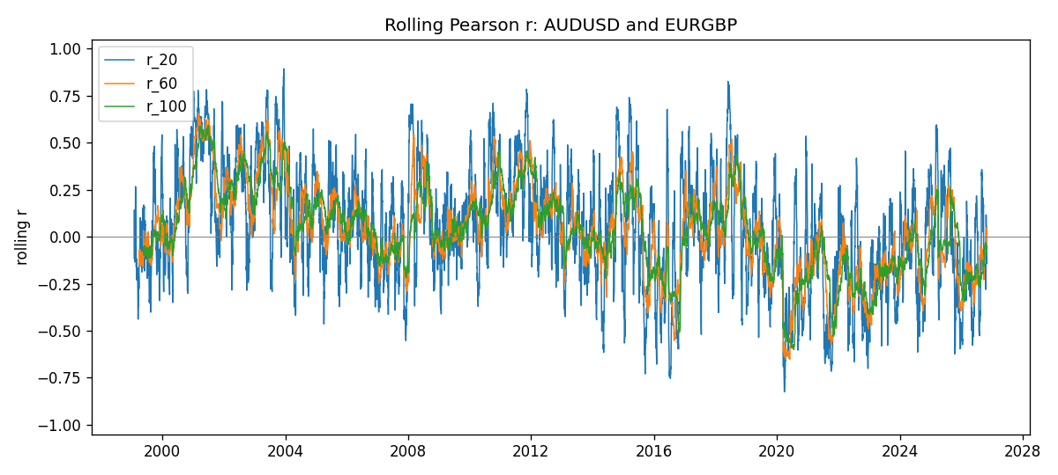
Daily closes

Daily log returns
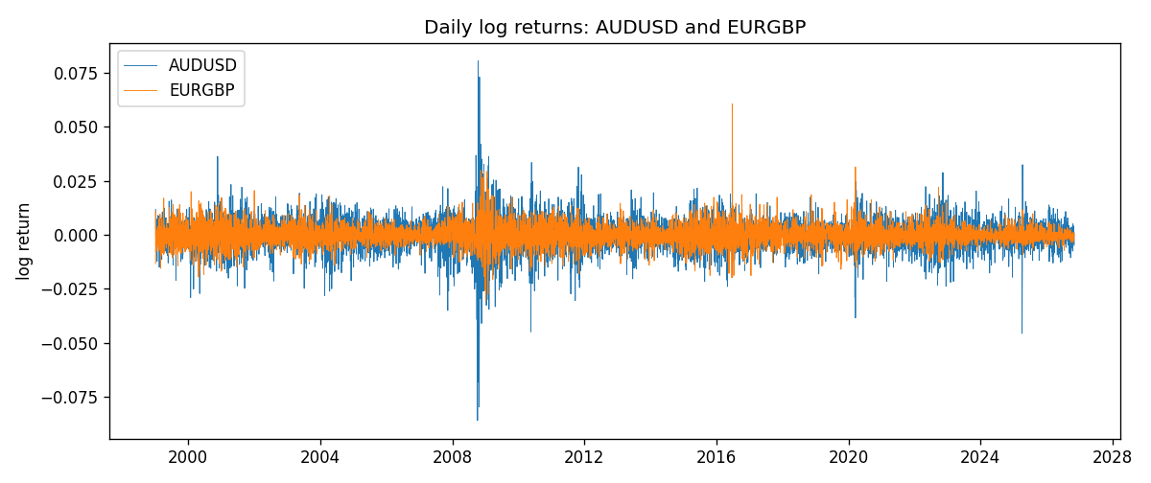

Data report
Every matched row with r_20, r_60, and r_100 is in the sibling CSV and HTML. This Word section holds column summaries and the first and last 15 rows of the rolling table.
Columns: time, AUDUSD_close, EURGBP_close, AUDUSD_tick_volume, EURGBP_tick_volume, AUDUSD_log_return, EURGBP_log_return, r_20, r_60, r_100
Column summaries
column | count | mean | std | min | 25% | 50% | 75% | max
AUDUSD_close | 7198 | 0.752069 | 0.135245 | 0.4786 | 0.661255 | 0.7318 | 0.809272 | 1.10169
EURGBP_close | 7198 | 0.786716 | 0.096752 | 0.5735 | 0.687525 | 0.83375 | 0.865285 | 0.977
AUDUSD_tick_volume | 7198 | 77378.2 | 138156 | 109 | 5445.75 | 43349.5 | 71356.8 | 1.23462e+06
EURGBP_tick_volume | 7198 | 86961.1 | 145397 | 332 | 6520.25 | 44270 | 81329 | 1.42468e+06
AUDUSD_log_return | 7198 | 2.054e-05 | 0.00754782 | -0.0860252 | -0.00386556 | 0.00027727 | 0.00415374 | 0.0806166
EURGBP_log_return | 7198 | 2.199e-05 | 0.00487197 | -0.0306737 | -0.00262256 | -0.00010006 | 0.00256155 | 0.0607539
r_20 | 7179 | 0.0468107 | 0.308699 | -0.825132 | -0.160493 | 0.0411125 | 0.25991 | 0.894461
r_60 | 7139 | 0.0389987 | 0.238606 | -0.651256 | -0.108648 | 0.0338044 | 0.196235 | 0.654989
r_100 | 7099 | 0.037674 | 0.221223 | -0.600576 | -0.106131 | 0.0319285 | 0.183984 | 0.592882
First 15 matched rows
time | AUDUSD_close | EURGBP_close | AUDUSD_log_return | EURGBP_log_return | r_20 | r_60 | r_100
1999-01-06 | 0.6289 | 0.7019 | 0.0118364 | -0.0133033
1999-01-07 | 0.6345 | 0.7097 | 0.00886503 | 0.0110514
1999-01-08 | 0.6347 | 0.7062 | 0.000315159 | -0.00494386
1999-01-11 | 0.6393 | 0.7053 | 0.00722138 | -0.00127524
1999-01-12 | 0.6362 | 0.7077 | -0.00486085 | 0.00339703
1999-01-13 | 0.6312 | 0.708 | -0.00789021 | 0.000423819
1999-01-14 | 0.6295 | 0.7066 | -0.00269692 | -0.00197936
1999-01-15 | 0.634 | 0.7012 | 0.0071231 | -0.00767158
1999-01-18 | 0.6346 | 0.7017 | 0.000945925 | 0.000712809
1999-01-19 | 0.6392 | 0.7007 | 0.00722252 | -0.00142613
1999-01-20 | 0.64 | 0.7021 | 0.00125078 | 0.00199601
1999-01-21 | 0.6405 | 0.7016 | 0.000780945 | -0.000712403
1999-01-22 | 0.6327 | 0.7004 | -0.0122527 | -0.00171184
1999-01-25 | 0.6302 | 0.6966 | -0.00395915 | -0.00544024
1999-01-26 | 0.6305 | 0.6962 | 0.000475926 | -0.000574383
Last 15 matched rows
time | AUDUSD_close | EURGBP_close | AUDUSD_log_return | EURGBP_log_return | r_20 | r_60 | r_100
2026-10-13 | 0.69821 | 0.84458 | 0.00350077 | 0.000201304 | -0.107759 | -0.0386604 | -0.036731
2026-10-14 | 0.69715 | 0.84553 | -0.00151932 | 0.00112419 | -0.079219 | -0.042828 | -0.0333455
2026-10-15 | 0.69191 | 0.84479 | -0.00754471 | -0.000875574 | -0.216615 | -0.00888388 | -0.0307728
2026-10-16 | 0.69426 | 0.84307 | 0.00339064 | -0.00203808 | -0.228924 | -0.022066 | -0.0403114
2026-10-19 | 0.6978 | 0.84259 | 0.005086 | -0.00056951 | -0.205509 | -0.0374939 | -0.0503049
2026-10-20 | 0.70022 | 0.83957 | 0.00346204 | -0.00359063 | -0.280633 | -0.054662 | -0.0627589
2026-10-21 | 0.70275 | 0.83839 | 0.00360664 | -0.00140647 | -0.0502498 | -0.0534666 | -0.0557939
2026-10-22 | 0.70186 | 0.83682 | -0.00126726 | -0.00187439 | 0.0795804 | 0.003261 | -0.0541074
2026-10-23 | 0.70353 | 0.83751 | 0.00237657 | 0.00082421 | 0.116708 | 0.0146349 | -0.0685914
2026-10-26 | 0.70128 | 0.83762 | -0.00320328 | 0.000131333 | 0.0495801 | 0.0510989 | -0.0709374
2026-10-27 | 0.70245 | 0.83595 | 0.00166699 | -0.00199573 | 0.0535902 | 0.0300263 | -0.0821943
2026-10-28 | 0.70533 | 0.83651 | 0.00409155 | 0.000669672 | -0.0587516 | 0.0370665 | -0.0730869
2026-10-29 | 0.70245 | 0.83553 | -0.00409155 | -0.00117222 | -0.0992129 | 0.0351865 | -0.0743948
2026-10-30 | 0.70316 | 0.83351 | 0.00101024 | -0.00242055 | -0.0516909 | 0.0244088 | -0.0769266
2026-11-02 | 0.69971 | 0.83426 | -0.0049185 | 0.000899405 | -0.141629 | -0.00373548 | -0.0941509

